ADDITIONAL USEFUL INFORMATION
A room reservation has been made for all participants at Varbergs Stadshotell Asia Spa in Varberg from October 18th to 19th. Price for one night in a single room including breakfast is SEK 1065:- incl. VAT
Please book your room accordingly by yourself referring to bookingnumber “020249” until September 16th. If booking of rooms is required for the night before and/or after meeting, please book this privately. It recommended to do as soon as possible (we have no reservations).
https://www.varbergsstadshotell.com/

PLEASE REGISTER HERE FOR THE SEMINAR:
http://www.winsverige.se/
The registration is binding.
All members from WiN are invited to hold lectures, contact Johanna Svahn, johanna.svahn@vattenfall.com (+46 725-384143) for more information.

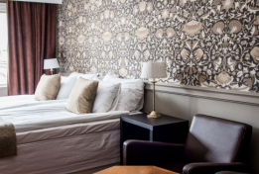
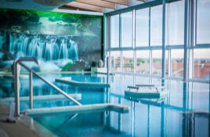
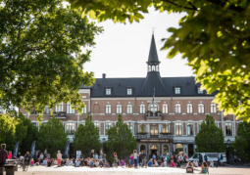
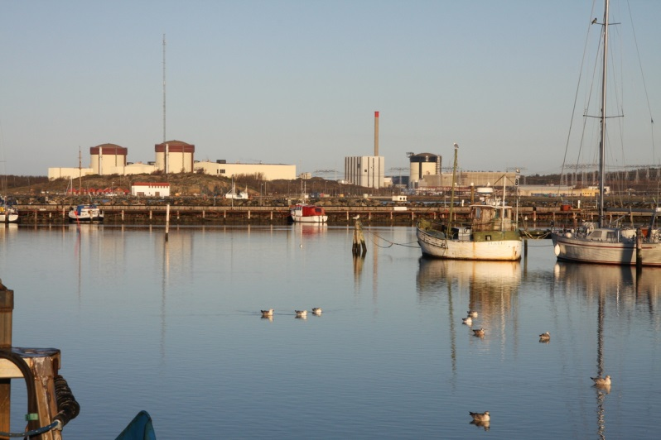
WiN Sweden and Germany Seminar
18th – 19th October 2018
Ringhals Nuclear Power Plant
Decommissioning in a sustainable way

18/10
09:00 - 12:00 Only for WiN members Sweden (se separately invitation)
Ca 11:00 - 12:00 Transfer from Landvetter Airport to Ringhals
12:00 WiN Germany arrive at Ringhals
12:00 - 13:00 Lunch in restaurant V2
13:00 - 13:30 VD Björn Linde, Welcome speech
13:30 - 13:45 WiN presidents - Welcome speech and start seminar
13:45 - 14:00 Information about Ringhals
www.visitringhals.se www.ringhals.se
14:00 - 15:30 Visit the plant (½ group)
Lecture Energiföretagarna
https://www.energiforetagen.se/
15:30 Coffee break
15:30 - 17:00 Visit the plant (½ group)
Lecture Energiföretagarna
https://www.energiforetagen.se/
17:00 - 17:30 Transfer to hotel
19:00 - 22:00 Dinner with group activity

19/10
08:00 - 08:30 Transfer from hotel to Ringhals
08:30 - 09:00 Drop In. Coffee and welcome back.
09:00 - 11: 00 Lecture from WiN Sweden or WiN Germany
11:00 - 12:00 Lunch V2
12:00 - 13:30 Lecture from WiN Sweden or WiN Germany
13:30 - 14:30 Kristina Gillian, Sustainable Decommissioning – What, Why, How?
14:30 - 15:00 Coffee Break
15:00 - 16:00 WiN presidents speech and end of program
Ca 16:00 - 17:00 Transfer from Ringhals to Landvetter Airport
